**ASSIGNMENT 8.3**

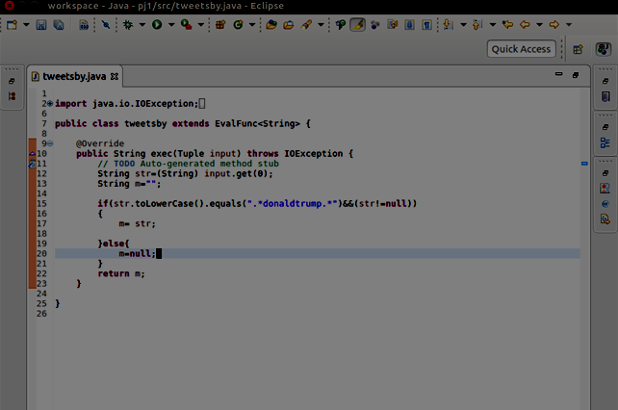

**OUTPUT**

**3218**